

Politecnico di Milano

A.A. 2016-2017

Software Engineering 2: PowerEnJoy

**I**ntegration **T**est **P**lan

*Lorenzo Frigerio (mat. 879203)*

*Martina Perfetto (mat. 808869)*

*Ivan Vigorito (mat. 879204)*

11th January 2017

*Version 1.0*

Indice

1. Introduction 2

1.1. Purpose and Scope 2

1.2. Glossary 3

1.2.1. Acronyms 5

1.3. References 5

2. Integration Strategy 5

2.1. Entry Criteria 5

2.2. Elements to be integrated 6

2.3. Integration Testing Strategy 6

2.4. Subcomponent and Subsystem Integration Sequence 7

3. Individual steps and test description 9

3.1. Business Logic (B) 9

3.2. Persistence Module Tests (P) 13

3.3. Car Test (S) 14

3.4. Subsystems Test (S) 14

4. Tools and test equipment required 16

5. Program stubs and test data required 17

5.1. Data required 18

# Introduction

## Purpose and Scope

This document explains a strategy to test all the components of the system.

Its overall purpose is to efficiently test everything and verify functional requirements and the reliability. Since the project is vast and complex, it is useful to make this document in order to have a solid point of reference about ways and techniques of testing, and a schedule about the order of components to be tested.

## Glossary

User / registered user: he/she is the client of the service; he/she is able to rent a car in order to travel around the city. He is associated with:

-Name

-Surname

-Other personal information

-Method of payment

-Number of driving licence and expiration date

-Password

Employee/operator: is the one that help users in case of emergency and has the responsibility of managing cars in case of malfunction. Users can call them by using the telephone exchange of the application.

Method of payment: is inserted by the user during the registration phase but can be updated over the time. Only one method is active at once and payment are concluded using services offered by the different companies holding the credit card. An invoice containing all the charges collected is generated monthly.

Car: sometimes referred as vehicle is the means of transport rented by users. It contains a set of sensors that analyse the number of passengers presents on the car, control the charge of the battery and detect when a door is closed. Moreover, it includes a module that transmit this information to the system using the Internet.

Available car: car that is not in use at the moment by any user, has at least 20% of charge and is not reserved by anyone.

Reservation: made by a user that wants to use a car. Has a duration of one hour maximum and is associated with a unique car. Once the user asks to unlock the car the car becomes associated to the user until he decides to end the ride.

Charge: amount of money that users have to pay due to the use of the service. It is immediately calculated by the system after a ride but money is transferred only at the end of the month.

Penalty: fee derived from a bad behaving of the user such as a damage on the car or a fine for exceeding speed limits. The fee will be notified to the user and included in the monthly invoice.

GPS navigation device: system that equip each car and that is able to calculate the exact position of the car and display to the user the route to follow. Its display is also used to show the current fee of the ride and the status of the battery.

Special Safe Area: special parking areas that contain plugs that allow cars to be recharged. They are provided with sensors that detect the number of spots that are currently used and communicate the number to the system. They are also called power grid stations.

Safe Area: Space included in boundaries that determine where users can park a car. It covers entire metropolitan cities in order to facilitate users to find a park and they may also contain power grid stations. Users cannot terminate a ride while outside from a safe area.

In this document we use ‘Safe Area’ to identify both Safe Area and Special Safe Area.

Ride/Rental: it last from when the user picks up the car until when the system stops charging the user. It includes a possible set of temporary stops and the total path travelled by the user.

Park: is when a user leaves the car and wants to end the rental. At this point the system stops charging the user.

Stop: is when a user leaves the car but wants to resume the ride in the future. The car will be locked by the system that, however, will continue to charge the user for the ride.

### 

### Acronyms

SPA: Special Safe Areas

SA: Safe Areas

## References

* Requirements and Specification Document, RASD
* Design document, DD
* IEEE Standards for Information Technology Systems, Design Document

# Integration Strategy

## Entry Criteria

Before starting the testing process there are several achievements related to the project that need to be performed.

Being the testing phase complex and long, it is important that each low-level component and function has been revised and approved from a code point of view with the code inspection, so as to avoid any kind of possible failure during the tests.

Moreover, the Design Document (DD) and Requirement Analysis and Specification Document (RASD) need to be fully completed and approved. The last one, allows the team to know all the aspects and environments in which our infrastructure will work in, but also the relations and boundaries of the system.

The integration phase should start only when the estimated percentages of completion of modules are:

* Total completion 100% for the Persistence Module
* At least 40% for client tier 1 (user application)
* At least 80% for client tier 2 (car)
* At least 70% for the car management
* At least 60% for the user management

All these percentages are obtained considering several aspects. In order to release a better product, it is important that the core functionalities are fully tested and available. This is the reason, we decided to assign an high grade of completion to some fundamental components. Furthermore, considering the time to fully perform the tests some percentages are also assigned taking into account the order of integration

## Elements to be integrated

The elements that we are going to integrate are the three component which we have already discuss in the Design Document. Each component implements a specific set of functionalities. They are:

* Business logic tier, that is the system main part and has the application logic inside;
* Persistence module, that stores and manages the data;
* Client tier, which is the part of the system that the client interacts with (web and mobile application and the car)
* External part, that is necessary for the system, is composed by sms and mail server for the client notifications and by a payment method.

## Integration Testing Strategy

The integration strategy is based on a bottom-up approach.

This decision comes from the fact that the small components of the infrastructure are tested and gradually integrated. Starting from easiest components increases the robustness and reliability of the system.

The initial components which are chosen to be tested, are selected owing to they don’t depend on other components to function. Different stubs are used during these phases replacing the other subsystems, which are not tested yet. After the testing of all the components that compose a subsystem ( in our case, the business logic is built up firstly), the subsystems are tested together.

This strategy of starting from the business logic and after go on with a bottom-up approach allows us to to spend more time and efforts upon the core aspects and functionalities of PowerEnJoy infrastructure.

## Subcomponent and Subsystem Integration Sequence

This diagram depicts the overview of all components but also the sequence in which they are integrated one after the other. The integration is based on a bottom-up approach, and the system is integrated starting from the business logic. After the tests inside the business logic, the persistence module is integrated.

Next, the client tiers are connected to the systems, they will create the environment for the system.

After that, external modules (such as mail server, sms server and payment system) are integrated in order to test the functionalities concerning the payment activities and the different notification methods.

It is clear that during the tests inside the business logic, a stub replaces all the services and data provided by the database (more information are provided inside the fifth paragraph).



Entity: User

User Management

Entity: Car

Entity: Ride

Entity: Safe Area

Reservation Management

Car Management

Maps Management

Notification Management

Entity: Employee



Database Structure (SQL File)

Database Management System



Mobile Application

Web Application

Car App Management



Sensor Management

Maps

Car Interface



Mail Server

Sms Server

Payment System

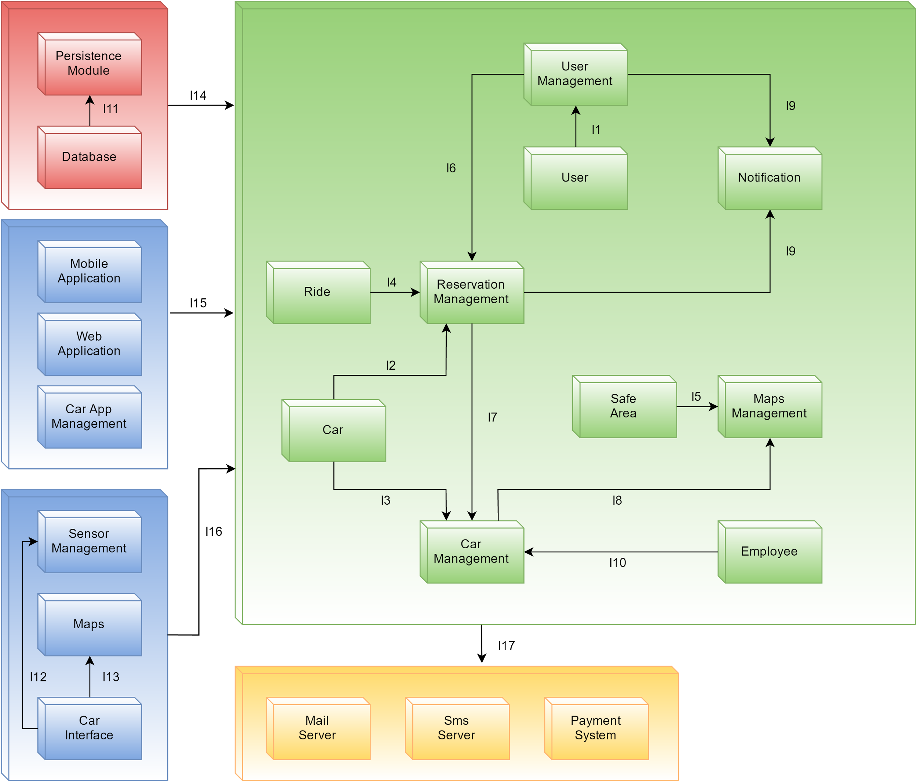

The diagram above deepens the description of integration sequence. The internal component of each subsystem is integrated following the specific numeric sequence. After the integration of all the subcomponent of a subsystem, the next step is to integrate two subsystems among themselves.

# Individual steps and test description

## Business Logic (B)

Test Case Identifier B I1 T1

Test Items(s) User → User Manager

Input Specification Generate typical User traffic

Output Specification Check User Management

Environment Needs N/A

The user traffic is generated in different possible ways: login access, sign-up or changing credentials. A possible exception could be raised when the user for instance introduces wrong credentials during the login. Another possible exception may occur during the sign-up when the user tries to introduce a wrong payment method.

Test Case Identifier B I2 T1

Test Items(s) Car → Reservation Management

Input Specification Test different rental activities

Output Specification Check Reservation Management

Environment Needs N/A

In this case will be checked if the user is able to reserve a car in a correct way, according to others requests.

Test Case Identifier B I3 T1

Test Items(s) Car → Car Management

Input Specification Generate car information exchange

Output Specification Check Car Management

Environment Needs N/A

During this phase is checked if the car is able to changing status and locking/unlocking activities.

Test Case Identifier B I4 T1

Test Items(s) Ride →Reservation Management

Input Specification Test different type of rides

Output Specification Verify the different responses

Environment Needs N/A

Check that each reservation generates a ride.

Test Case Identifier B I5 T1

Test Items(s) Safe Area → Maps Management

Input Specification Test with different safe areas

Output Specification Check responses

Environment Needs N/A

Test will be executed with different request on isInsideSafeArea() method. In addition it will be tested that CalculateRoute() generate destination inside a SafeArea.

Test Case Identifier B I6 T1

Test Items(s) User Management→ Reservation Management

Input Specification Test reservation with valid and not valid users

Output Specification Check the validity of the results

Environment Needs I1, I2, I4 test succeeded

Test will be executed over different kinds of users. An exception will be generated in case the user does not have a valid driving licence or in case he has not paid the last monthly invoice

Test Case Identifier B I7 T1

Test Items(s) Reservation Management→Car Management

Input Specification Different requests performed with all possible combination of status

Output Specification verify that all the status are updated correctly

Environment Needs I2, I3, I4 test succeeded

Test will be executed by updating a car status with the different possible status. Exception will be raised in case a car status could not be updated such as when an InRide car is asked to pass to underChargeAvailable directly without passing from Available. In addition other exceptions are raised when the car is asked to open unlockCar(Car car) or to close when the car is not under reservation

Test Case Identifier B I8 T1

Test Items(s) Car Management→Maps Management

Input Specification Invoke functions with valid and invalid parameter

Output Specification Verify that maps are returned correctly

Environment Needs I5, I7 test succeeded

The Car Management traffic is composed of requests of calculating a route and isInsideSafeArea(). Exception are raised in case the departure or the destination of a route are not correct or when one of the parameters is missing.

Test Case Identifier B I9 T1

Test Items(s) User Management, Reservation Management →Notification Management

Input Specification SMS and EMAIL requests are checked

Output Specification Check notification behaviour

Environment Needs I6, I7 test succeeded

The integration test the Notification Management to verify the correct behaving of the component.

Test Case Identifier B I10 T1

Test Items(s) Employee→Car Management

Input Specification Manage employee’ status

Output Specification Check behaviour

Environment Needs N/A

The integration test checks the correct behaving of the component.

## Persistence Module Tests (P)

Test Case Identifier P I11 T1

Test Items(s) Database → Persistence Module

Input Specification Create queries

Output Specification Check database structure and concurrency

Environment Needs N/A

Exceptions are raised if the query is invalid or returns no parameter

## Car Test (S)

Test Case Identifier C I12 T1

Test Items(s) Car Interface→Car Maps

Input Specification Different requests to show and update maps

Output Specification Verify that maps are displayed correctly

Environment Needs N/A

The test verifies the behaving of car when showing maps and perform requests to calculate the correct route.

Test Case Identifier C I13 T1

Test Items(s) Car Interface→Car Sensor Management

Input Specification Different requests to test all the sensors in different circumstances

Output Specification Verify that results are returned correctly

Environment Needs N/A

The test is based on verify the behaving of all the sensors present on the car, such as the one that calculate the number of passengers on the car and the one on the battery level. Exceptions are raised in case one the sensors do not behave correctly

## Subsystems Test (S)

Test Case Identifier S I14 T1

Test Items(s) Persistence Module → Business Logic

Input Specification Different entities to be stored or updated

Output Specification verify the presence of the entities in form of tuples

Environment Needs I10 test succeeded

All the different functions provided by the persistence module are tested. Exceptions are raised when the Persistence Module is not able to connect to the DataBase or when the DataBase notify a consistency problem, such the request to register of a user already registered in the application.

Test Case Identifier S I15 T1

Test Items(s) Client Tier 1 → Business Logic

Input Specification Generate typical client traffic

Output Specification Check the result of the operations

Environment Needs B block test succeeded

The interaction between business logic and the applications could raise exceptions. It happens when the applications make invalid requests, for example when the user try to make a reservation but he’s not logged

Test Case Identifier S I16 T1

Test Items(s) Client Tier 2 → Business Logic

Input Specification Generate typical car requests (e.g. get the route)

Output Specification Check the validity of the result

Environment Needs B block test succeeded

Exceptions are raised when inputs are invalid or null

Test Case Identifier S I17 T1 Test Items(s) Business Logic →External Application

Input Specification Simulate the use of Payment Method as external Application

Output Specification Check the correctness of all functionalities related to payments and invoices

Environment Needs block B and P test succeeded

The business logic needs to check the compatibility and the functionalities of external applications. In this test the business logic uses some services provided by the payment method. The possible exceptions which may be raised concern a wrong payment method introduced by the user during the sign-up phase (checked with the method checkPayment() described in DD). Another possible exception is raised when the user tries to pay with an outdated / expired payment method.

Test Case Identifier S I17 T2

Test Items(s) Business Logic → External Application

Input Specification Send notification through Sms or Mail

Output Specification Notification sent

Environment Needs block B and P test succeeded

The business logic has to interact with its registered users. For example, the users, as soon as they send the registration form, receive a password in their mail box. They also receive notification through sms by the business logic. In the case in which a user inserts a wrong email, during the signup form the business logic will not be able to send the registration password and a particular exception will be raised in order to remove this registered user with a wrong mail.

# Tools and test equipment required

In order to perform the integration some tools are used to test functional and non-functional requirements:

NON-FUNCTIONAL REQUIREMENTS:

* Apache JMeter: It is used to simulate heavy load on a server or object to analyse the performances. In this case the tool is used to test the responses of the application server to an heavy load of requests especially during specific hours of the day.

FUNCTIONAL REQUIREMENTS:

* Mockito: It is the software used to create the three main stubs required and to do unit tests.
* JUnit: It is used for the integrations of subsystems
* Manual testing: finally, a user simulates the behaving of the systems under the different requests to verify the overall

The integration testing phase described in this document requires a specific testing environment. Therefore, some equipment are necessary to make the integrations phase. As regard to the Business Logic and the Persistence Module a cloud infrastructure is necessary to simulate the real environment where per system is going to be executed. On the other hand, a set of three devices using the three different OS. chosen is necessary to perform the final tests of the performances of the mobile application. However, an emulator of the three devices is sufficient during the testing phase. Finally, a personal computer is used for testing the web application and the Car Management Application of the employees.

# Program stubs and test data required

Having followed a bottom up approach we reduced as much as possible the necessity of stubs. However, in some circumstances they revealed to be still useful to replace part of the code not yet integrated. During the integration process, in fact, stubs are necessary when:

* Persistence Module: In this case a stub replaces the whole database until I11 that is when the module is integrated with the business logic. Until that moment a stub implemented with the same interface of the Persistence Module replace that component and return dummy results to the requests of the Business Logic. This approach is facilitated by the use of a repository pattern that separates in an easy to manage way the business logic from the retrieval of data.
* External Module:
  + Payment System: A stub is used to replace the payment system until I11 to simulate its functioning during the testing of the business logic. The stub will be pre-written to answer to the requests performed.
  + SMS and Mail Server: A stub replace this components during the testing of the notification component by simply simulate the sending of mails and SMSs.

## Data required

For each interface, we illustrate all the methods and the data required, followed by the input that can generate some errors.

* DB Service

+insertUser(User usr)

+insertReservation(Reservation reserve)

+insertEmployee(Employee empl)

+insertRide(Ride rid)

+insertCar(Car car)

+modifyUser(User usr)

+updateStatus(Status stat, Car car)

– Null object

– Invalid value, for example an employee’s matriculation number is a wrong value or the card of the user has expired

– An object User, Reservation, Employee, Ride or Car already exists in the database

* Reservation

+reserveCar(String username, Car car, Date reservation_date, Time reservation_time)

+searchAvailableCar(GPSData local)

+searchAvailableCar(String departure_address)

+unlockCar(Car car, String username, GPSData local_user)

– Null object

– Invalid value, for example a gpsdata correspond with a wrong position or the date and time are in the future, or try to unlock the car when its status is free

* Ride

+beginRide(Car car, Reservation reserv)

+endRental(Car car)

– Null object

– Some incompatible objects, for example the car does not correspond with the reservation’s car

* Map Management

+calculateRoute(String departure, String destination)

+isInsideSafeArea(Car car, GPSData local_car)

– Null object

– Invalid value, like an erroneous gpsdata

* Status

+lockCar(Car car)

+unlockCar(Car car)

+getCarPosition(Car car)

+updateStatus(Car car, Status stat)

– Null object

– Invalid value, for example a wrong status for the car

* User Manager notification

+sendEmail(String email, String event_type, String user_destination, String password)

+sendNotification(String username, String event_type, String event_id)

– Null object

– Invalid value, like a wrong email

– Some incompatible objects, the email does not correspond with the user’s email

* Payment Method

+checkPayment(Data payment)

+payInvoice(Data invoice)

– Null object

– Invalid value, for example a data in the future